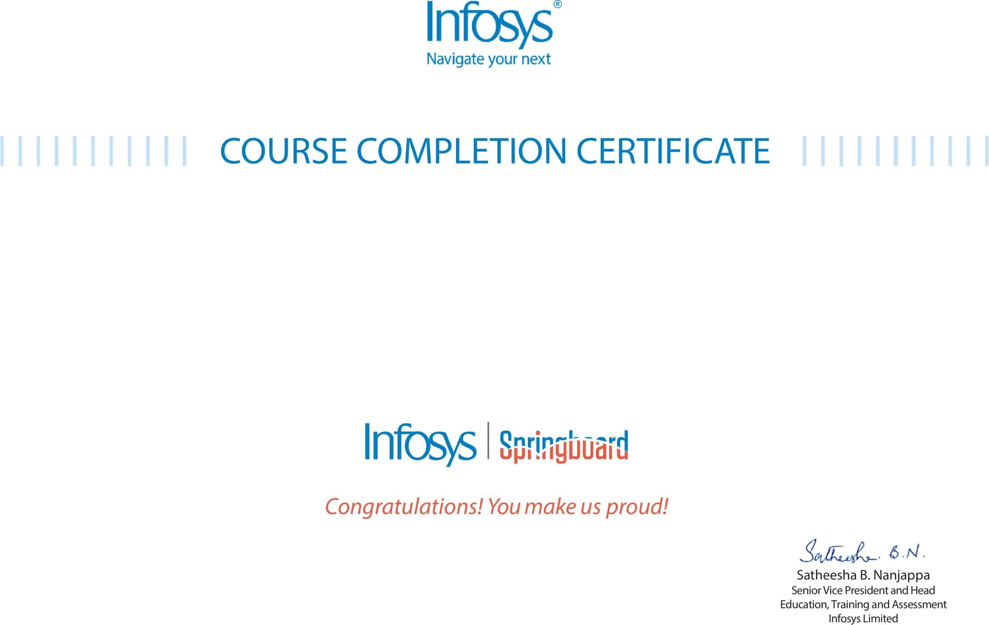
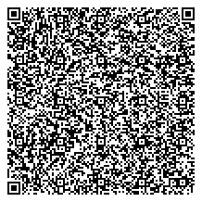

The

certificate

is

awarded

to

VUNGARALA NANDA SRINIVAS

for

successfully

completing

the

course

NodeJS

Case

Study

-

Movie

App

on

Node

JS

and

MongoDB
on

April

17
,

2026

Issued

on:

Saturday,

April

18
,

2026

To

verify,

scan

the

QR

code

at

https://verif
y

.onwingspan.co
m

